Nama : Faza Izzaturrafi

Kelas : TPL A/P1

NIM : J0403241102

**Latihan 1: List**

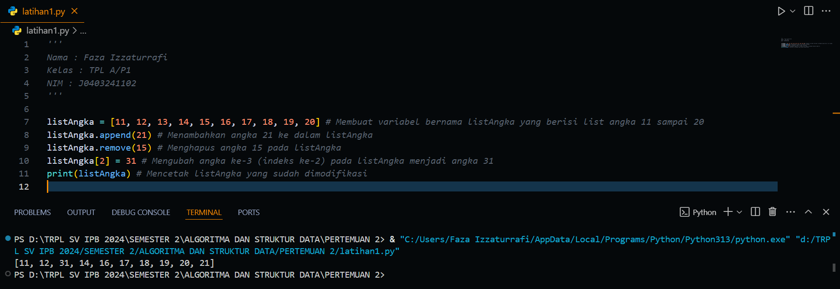

**Latihan 2: Tuple**

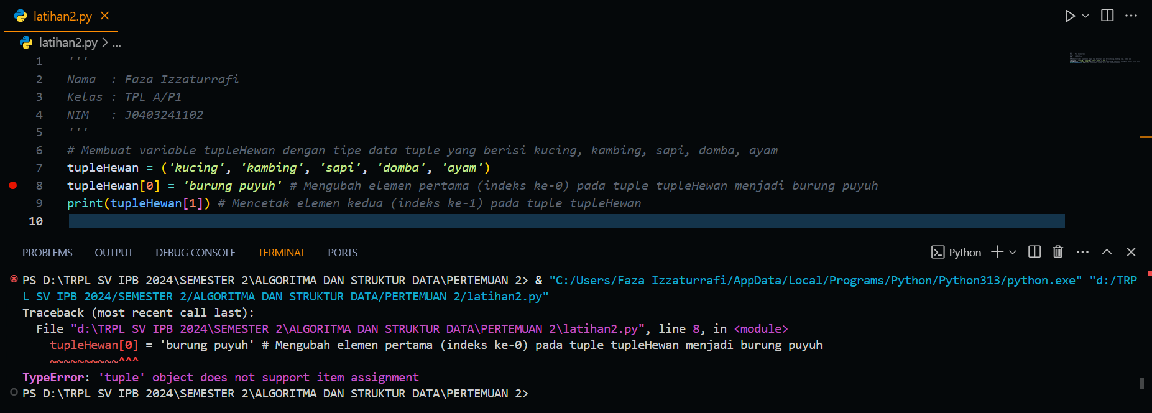

**Latihan 3: Set**

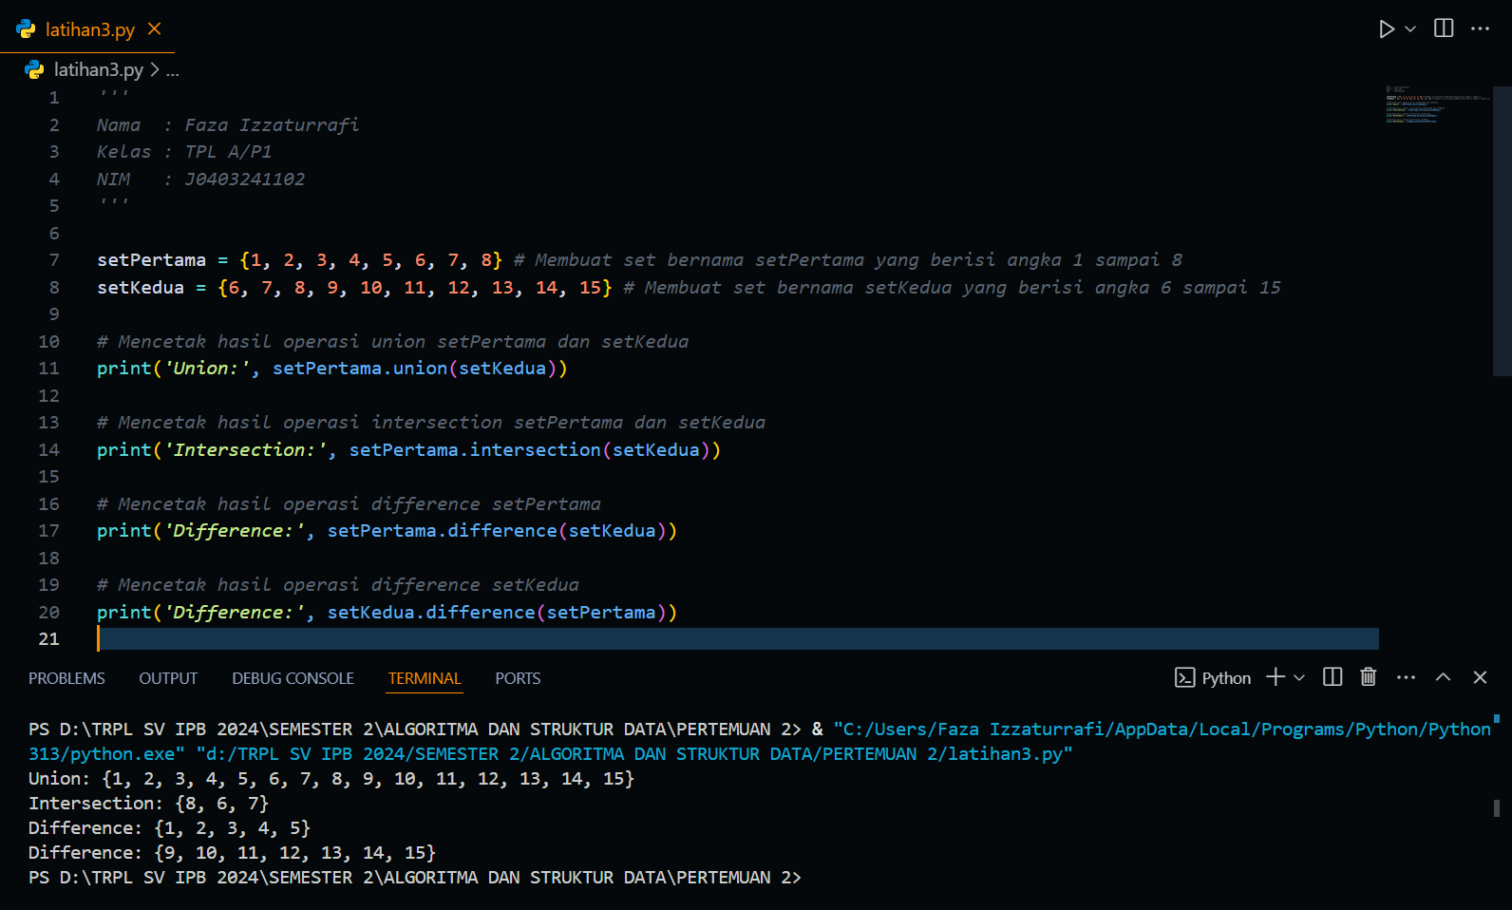

**Latihan 3: Dictionary**

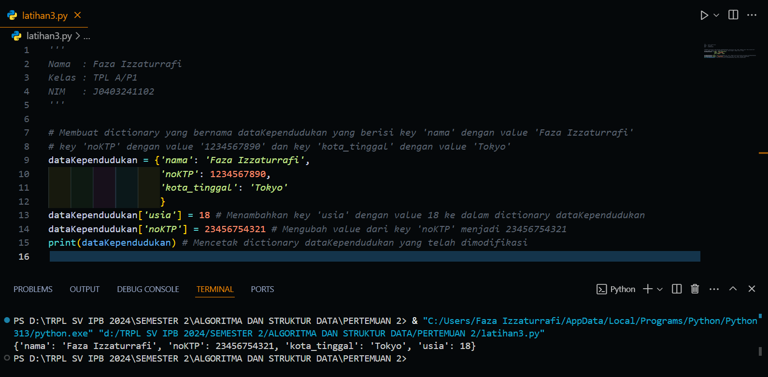

**Tugas Individu (Mini Project)**

